LHS Rebel Band Booster Executive Board
September 12, 2022
6:00pm/LHS Band Hall

Board Members in Attendance:
Amber Pena, President
Christina Valencia, Vice-President
Jeanette Reyes, A/R Treasurer
Gloria Munoz, Fundraising
Helga Hoban, A/P Treasurer
Larry Lozano, Communications
Robert Pena, Pit Boss
Traci Tercero, Secretary

Others in attendance:
Steven Dojahn, LHS Band Director

Proceedings:
- Meeting called to order by Amber Pena at 6:01 pm

- August meeting minutes were reviewed, and approval was motioned by Helga Hoban and seconded by Christina Valencia

Fundraising Update (Amber Pena and Gloria Munoz):
- Discussed issues with Brand-in-Iron not filling orders in a timely manner, causing us to lose business due to not having shirts on hand (some shirts ordered a month ago have yet to be delivered)
  - We are unsure about ordering more inventory that might not be delivered in time to sell
  - Mr. Dojahn will speak with Pam about the issues and explain that we might need to find another vendor to order from
- Three stand up racks were purchased for about $200 for spirit sales (makes transport much easier)
- First profit sharing night will be at Mr. Gatti’s on September 22nd from 6pm-close (Mr. Dojahn asked for a graphic to help spread the word)
- Upcoming fundraisers
  - Widdyup- September
  - World’s Finest Chocolate- October
  - Texas Roadhouse Roll- November

Payables Treasurer Report (Helga Hoban):
- Reported that we have exceeded the budget amount for item 6404 Props/Supplies/Uniforms (will supplement from the increased donations we have received this year)
- All other budget items currently looking good
- Reported that a fourth of the students are not paying assessment payments on time

Receivables Treasurer Report (Jeanette Reyes):
- Due to Dina Higginbotham’s job situation changing, she has stepped down from the A/R Treasurer position into an assistant role- Jeanette Reyes has agreed to step into the treasurer role (this motion was approved by the Booster Executive Board via email)

- Jeanette presented a sponsorship report
  - We have 46 sponsors (a big increase from last year!)
  - $30,200 have been collected so far (waiting for payment from three)
  - $7220 have been credited to students
  - Henry Resources is working on a large donation and will get solo recognition
  - Discussed the status of logo procurement for the website and the show shirt
    - Due to the large number of sponsors, we might have to modify the show shirt with either two printings or logos on the front and back
- Also, a deposit report was submitted, with the following categories listed:
  - Band Assessment- $24,311
  - Guard Assessment- $1650
  - Instrument Rental- $1735
  - Corporate Sponsorships- $24,655
  - Booster Club Memberships- $1220
  - Spirit Sales- $4762
  - Yard Signs- $1575
  - Concession Sales- $613
  - Under Uniform Sales- $1700
  - Marching Shoe Sales- $4471
  - Polo Shirt Sales- $1875
  - Water Jug Sales- $420
  - Front Ensemble Jersey Sales- $460
  - Total- $69,446
- Discussed what to do with a $443.74 PayPal balance left over from last year- decided to transfer to the miscellaneous budget item
- Jeanette has created a spreadsheet loaded on Google detailing payments for items such as polos and under uniforms
- Assessment payment update
  - 33 students have paid in full
  - 49 students have paid >$200 (payments on track)
  - 56 students have paid <$200
  - 78 students have not paid anything
- Mr. Dojahn discussed wanting a checklist when students leave the program so that items are taken care of (i.e., assessments payments) before allowing the schedule change

Vice President Report (Christina Valencia):
- Platoon Parents
  - Still need many students and parents to sign up for section bands on the Band app (Mr. Dojahn will share the QR codes to help facilitate the sign ups)
  - Still need a flute parent to sign up as platoon parent (Mr. Dojahn to work on this)

President Report (Amber Pena):
- Band mom Crystal Baylor has received a volunteer award with her company and an accompanying $26,000 grant from the Ken Davis Foundation to the non-profit(s) of her choice (we will split the money with Legacy Orchestra), and we can apply for this grant again year after year
- Widdyup fundraiser has a soft start today and hard start on Thursday (after Ms. Henshaw leaves) and will run through October 3rd
  - Students will create an account and a pitch video
  - Then they will upload a talent video that can be watched after a donation is made (can be a personal video, a group video, or a whole band video)
  - The link can be shared via multiple sources to reach a large group of people
  - Widdyup takes 5%, the boosters get 10% and the students get 85%
    - Incentives are being developed as rewards for participation and the amount of funds raised (individual, section and whole band)

Membership Report (Amber reported):

Uniform Report (Amber reported):

Hospitality Report (Amber reported):

Pit/Props Report (Robert Pena):

Colorguard (Amber reported):

Communications Report (Larry Lozano):

Director Report (Steven Dojahn):

New Business:
- None Reported

Next Meeting
- Monday, October , 6pm in the Band Hall

Meeting was adjourned at 7:50pm

Submitted by Traci Tercero
Booster Board Secretary

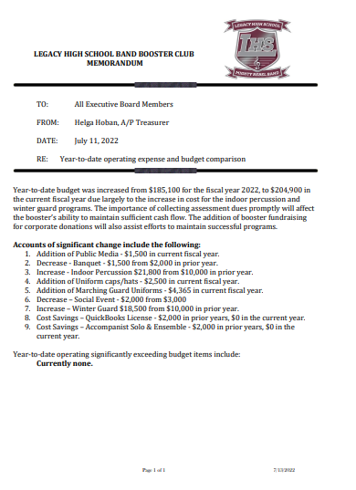
Addendum

